**ACTION: Stop Exposed Postman Credential / Collection to Public**

Step 1: Open the Postman in your local desktop or browser.

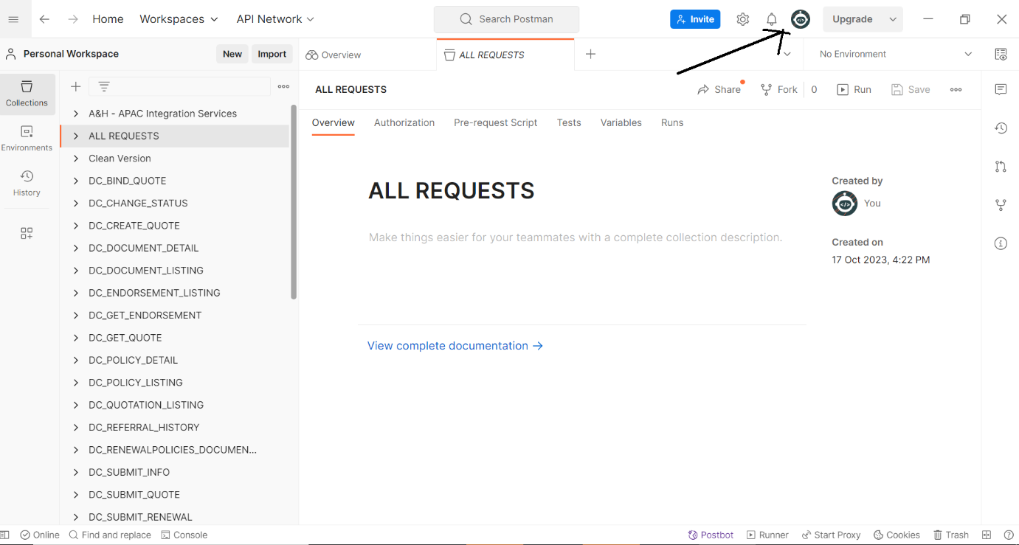

Step 2: Click the Profile icon -> Click ‘View Profile’ it will redirect to the browser.

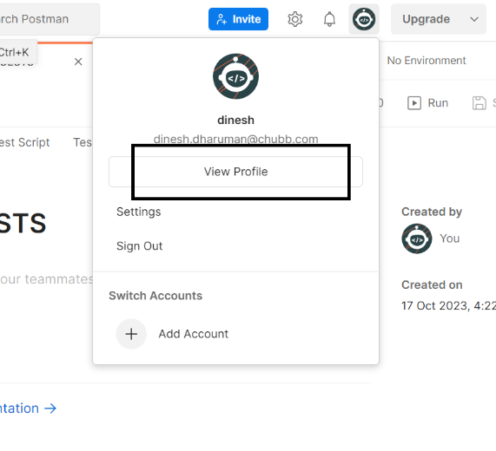

Step 3: **Browser postman view**:

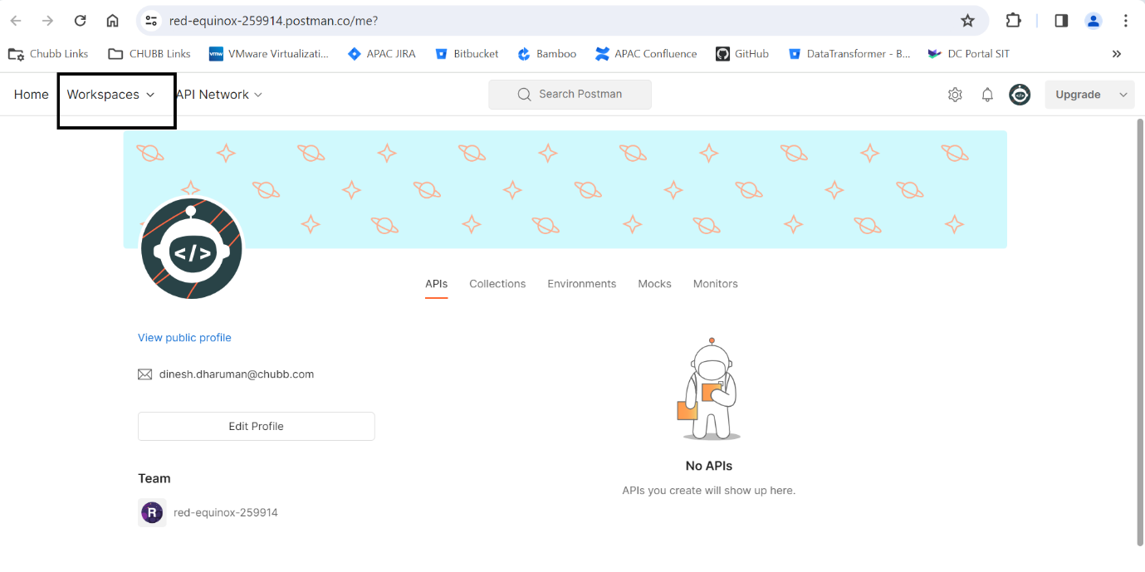

Step 4: Once you have landed in the browser, select the ‘Workspace’ drop down -> In that drop down select the respective workspace. (if you have multiple workspaces, select each one of them one by one and apply the settings.)

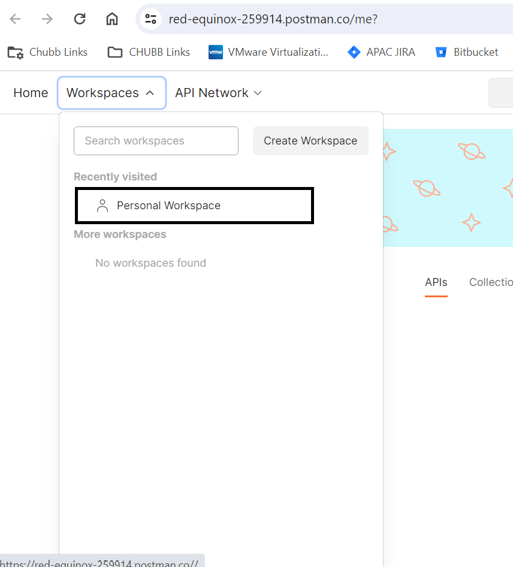

Step 5: Selected workspace it will look like below. Click -> ‘Workspace Settings’

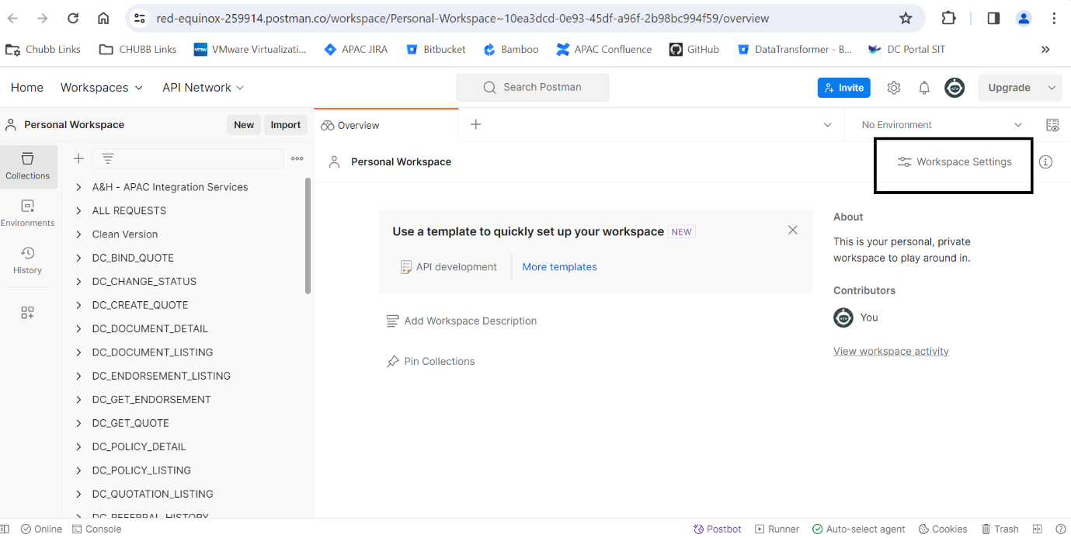

6. Click the ‘Workspace Settings’ -> Visibility options.

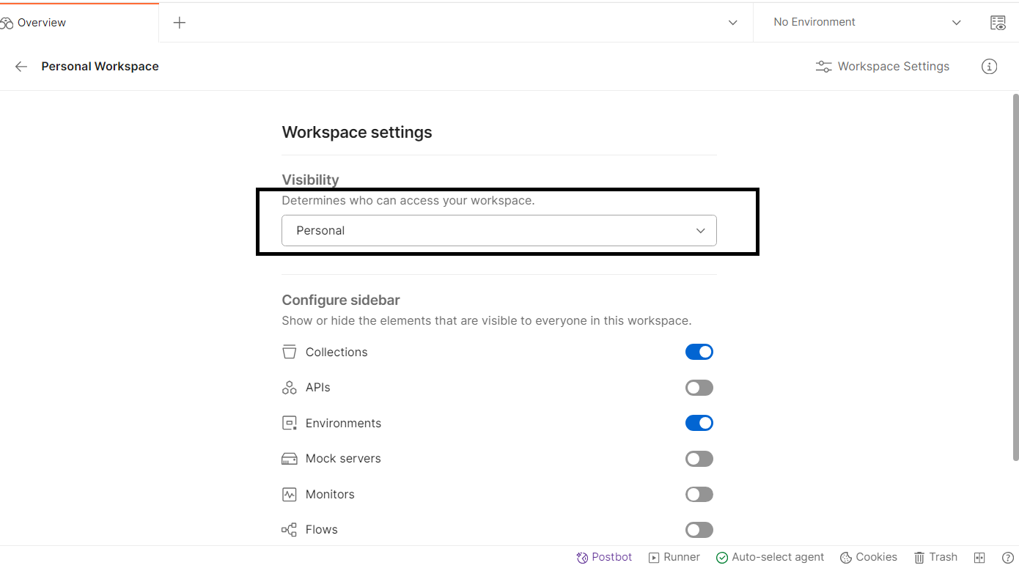

7. In the Visibility dropdown - > should select ‘Personal’.

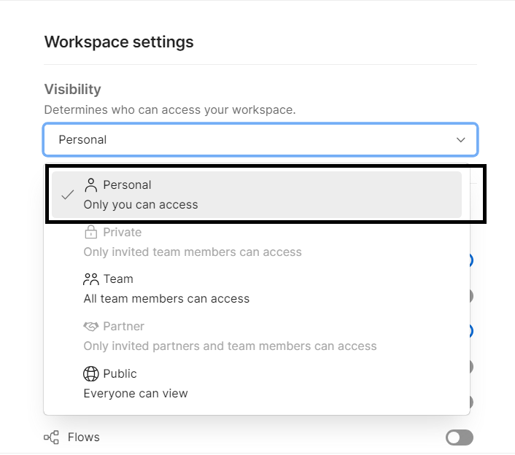

Step 8: Under Profile -> Click ‘Edit Profile’.

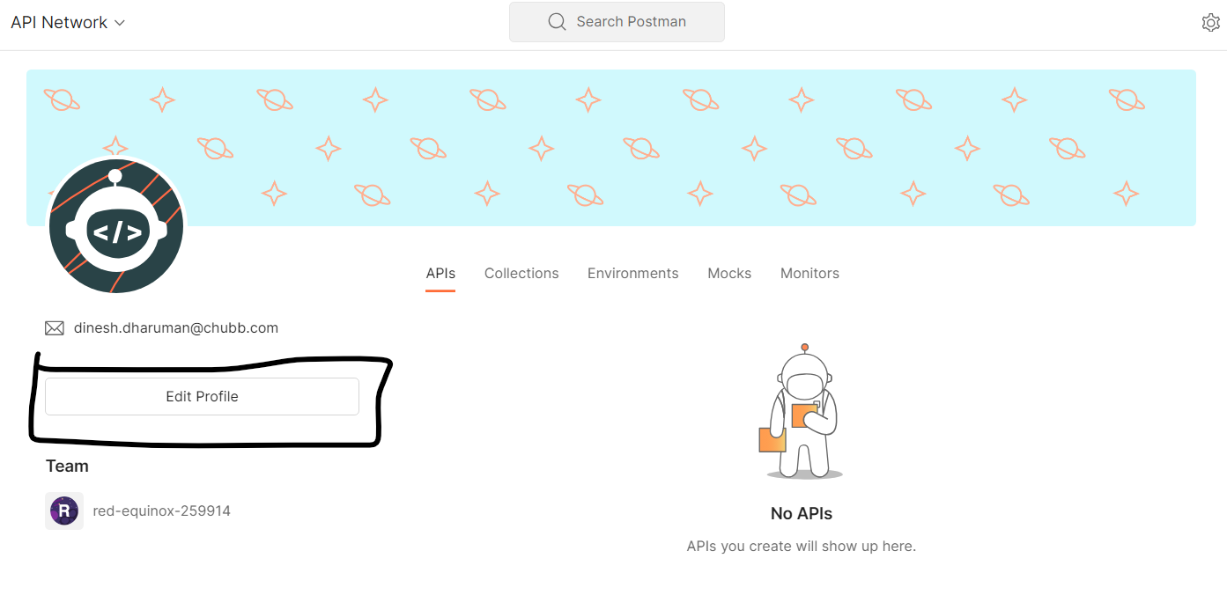

Step 9: Make sure to uncheck this check box (Make my profile public) and update the profile -> Click ‘Update Profile’ button.

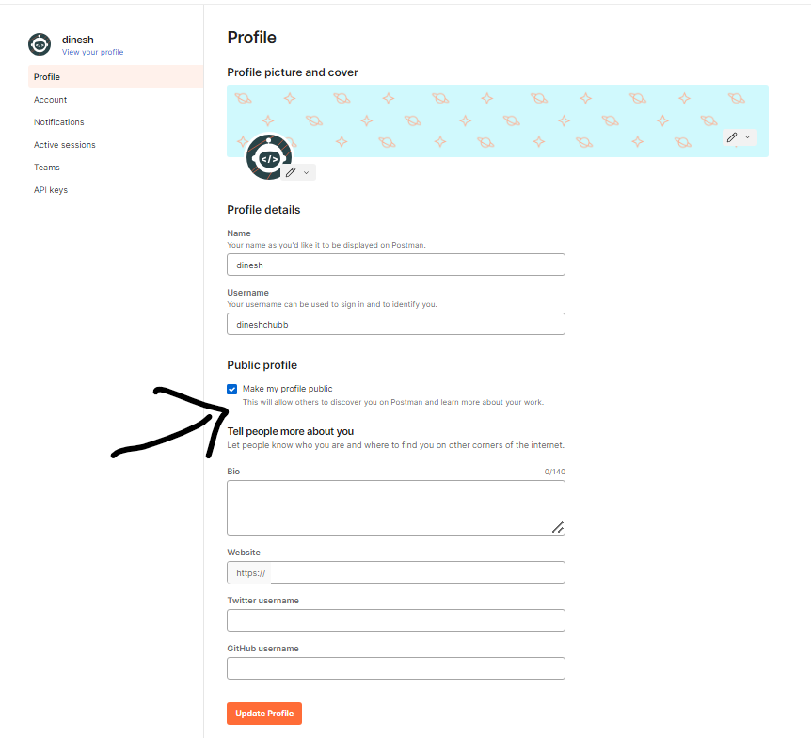

Note : If you and your team is using ‘Teams’ in postman please ensure to make the collections and workspaces as **personal or private**